Common workflow:

1. Create a branch for a desired feature

command :

git branch script-new

git branch

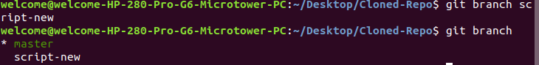

\* next to the master represents the branch I am currently working on.

Further, check out that branch using

command: git checkout script-new

git branch

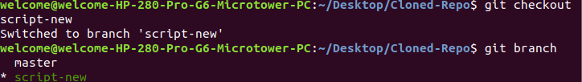

Now make changes in script.py file and git status

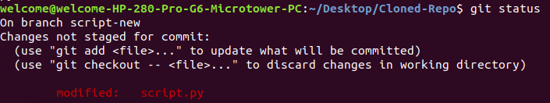

Now add those changes

git add -A

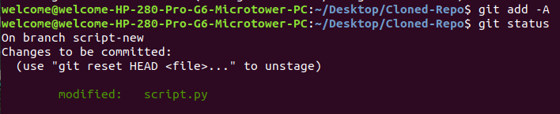

git commit -m “script branch and script modified” -

this has no effect on local master branch or the remote repo

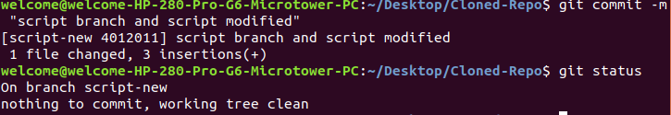

1. After commit, push this branch to remote

command: git push -u origin script-new - here origin is the repo name and script-new is the branch name

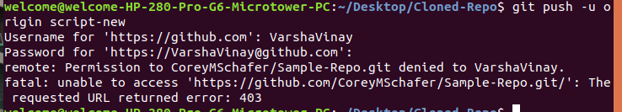

git branch -a

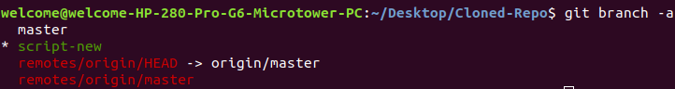

1. Merge a branch:

checkout local master branch or switch to master branch using

command : git checkout master

next pull the changes of the master if anyone has made any changes using

command: git pull origin master

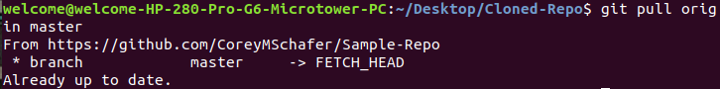

next to see the branches that we have merged in so far using command:

git branch --merged

